

**Chatbot Deployment with IBM Cloud Watson Assistant**

**Development-2**



Chatbot Deployment with IBM Cloud Watson Assistant

**IBM Cloud Account:**

**Sign up for an IBM Cloud account if you haven't already.**

**Set Up Watson assistant:**

**Create an instance of the IBM Cloud Watson assistant service in your IBM Cloud account.**

**1.The Chatbot Persona:**

**Determine the chatbot's personality and tone (e.g., formal, casual, friendly).Understand the target audience and their expectations.Start by defining your chatbot's persona. Is it a helpful assistant, a virtual customer support agent, or something else? Choose a name and character for your chatbot to make it more relatable.**

**2. The Purpose:**

**Determine the primary goals and objectives of the chatbot.**

**Decide what kind of queries or tasks the chatbot should handle.**

**3.Conversation Flow:**

**Identify the primary use cases or scenarios your chatbot will handle. For instance, if it's a customer support bot, consider scenarios like FAQs, troubleshooting, or product information.**

**Design a conversation flow for each scenario. Create a flowchart or diagram to outline how the conversation will progress, including user inputs and bot responses.**

**4. Configure Intents:**

**Create a list of user intents (queries or requests) that the chatbot should recognize.**

**For each intent, provide examples of user input to train the chatbot.**

**Assign descriptive names to the intents (e.g., "OrderPizza," "CheckWeather").**

**5. Define Entities:**

**Identify specific entities (variables or data) that the chatbot needs to extract from user input.**

**Define synonyms for entities to capture variations in user input.**

**Assign types to entities (e.g., "Location," "Product").**

**6. Design Conversation Flow:**

**Create a flowchart or diagram outlining the expected conversation path.**

**Define the welcome message and initial user prompt.**

**Determine how the chatbot responds to each intent and entity.**

**Plan for error handling and fallback responses.**

**7. Configure Dialog Nodes in Watson Assistant:**

**Map intents to dialog nodes. Each node should handle a specific intent.**

**Set conditions for when a node should be triggered based on user input.**

**Define responses for each node, including dynamic responses that use extracted entities.**

**Implement branching and context management for multi-turn conversations.**

**8. Test and Refine:**

**Test the chatbot with a variety of sample user inputs.**

**Make adjustments to intents, entities, and dialog nodes based on test results.**

**Continuously refine the chatbot's responses and performance.**

**9.Integration:**

**Integrate your chatbot with the platform or channels where it will be used, like a website, mobile app,facebook,slack or messaging service.**

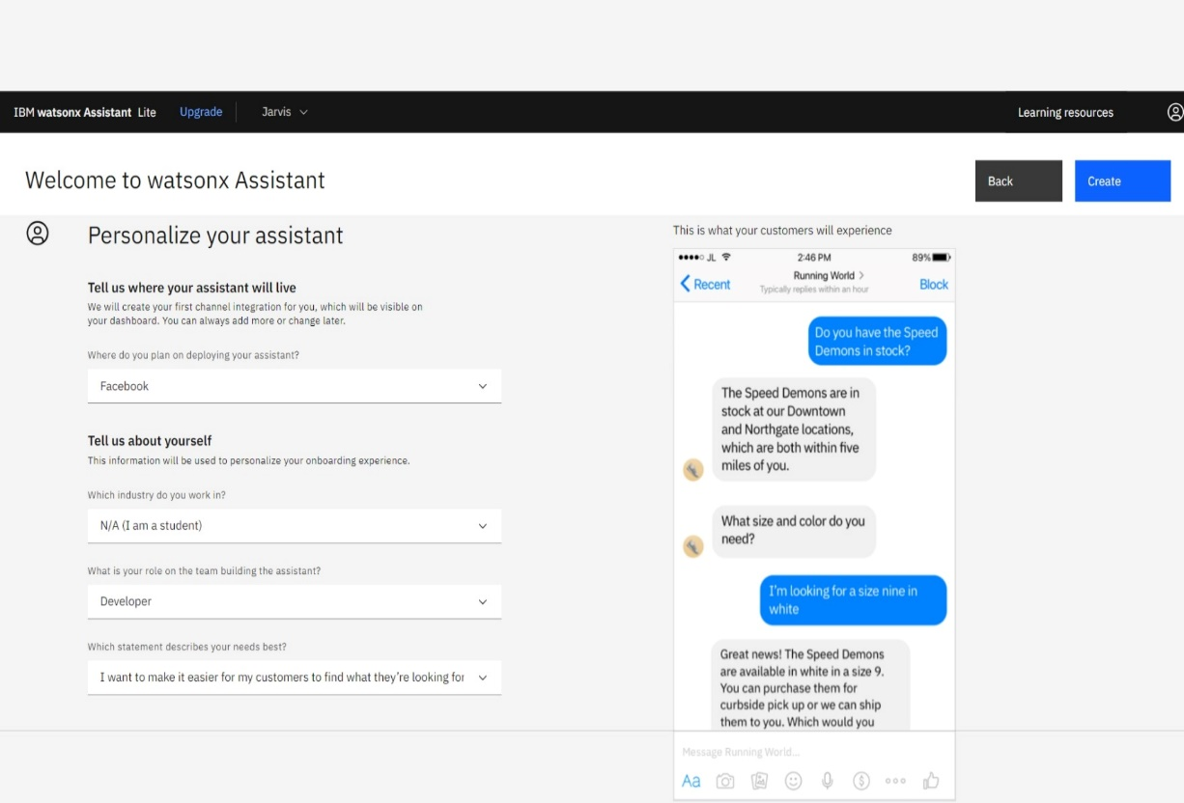

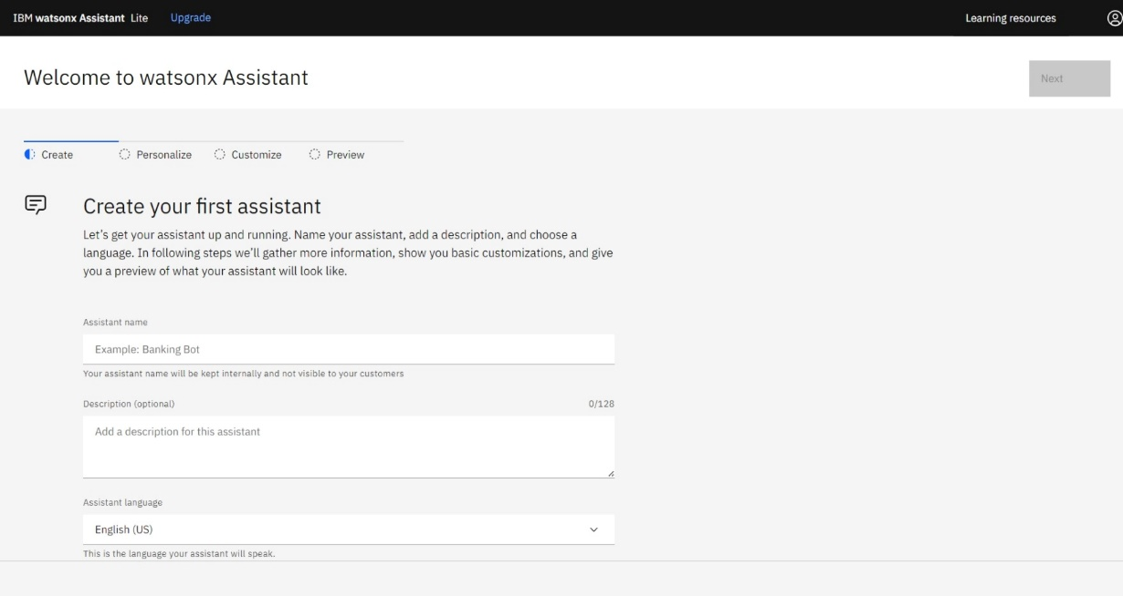

**Log in to IBM Cloud:**

**Go to the IBM Cloud website and log in to your account.**

**Navigate to Resource Groups:**

**Once logged in, click on the "Resources" section in the IBM Cloud Console.**

**Create a New Resource Group:**

**In the Resource Groups section, you should find an option to create a new resource group. Click on it.**

**Actions:**

**Actions are used to define custom logic or to trigger specific behaviors in response to user input. They can involve setting context variables, generating responses, or making external API calls.**

**Actions are custom code or logic that the chatbot can execute in response to user input. This might involve making API calls, modifying context variables, or other custom behavior.**

**Preview:**

**1.Testing Your Chatbot Logic:**

**When you're building or updating a chatbot in Watson Assistant, you can enter preview mode to test how the bot responds to different user inputs. This is especially useful for checking the dialog flow, intent recognition, and entity extraction.**

**2. Simulated Conversations:**

**In preview mode, you can simulate conversations by typing messages as if you were a user interacting with the chatbot. The chatbot responds based on its dialog nodes, intents, entities, and actions that you've defined.**

**3. Debugging and Validation:**

**You can use preview mode to identify and fix issues in your chatbot's responses, such as incorrect answers or unexpected behaviors. It's a valuable tool for debugging and fine-tuning your chatbot.**

**4. No Impact on Live Environment:**

**The important thing to note is that when you're in preview mode, the changes you make or the conversations you simulate do not affect the live deployment of your chatbot. It's a safe sandbox for testing.**

**5. Context Awareness:**

**Preview mode retains context from one user message to the next, allowing you to test multi-turn conversations and ensure that context variables and actions behave as intended.**

**6. Preview Mode Limitations:**

**While preview mode is helpful for initial testing and validation, it may not fully replicate the exact user experience, especially if your chatbot relies on external integrations or real-time data.**

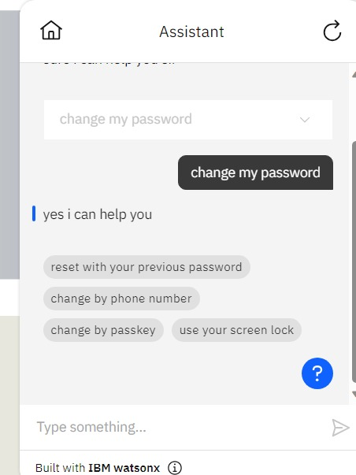

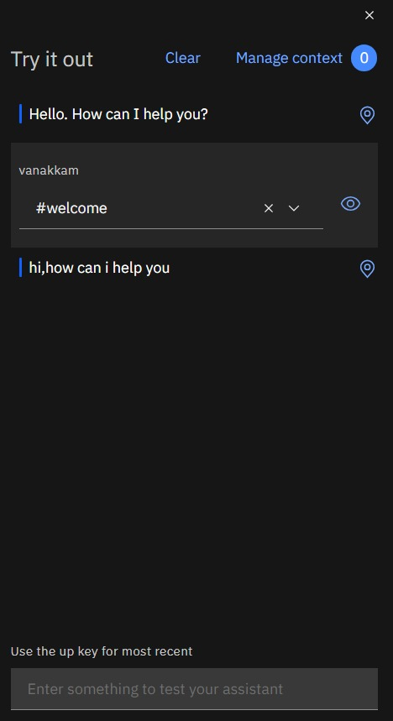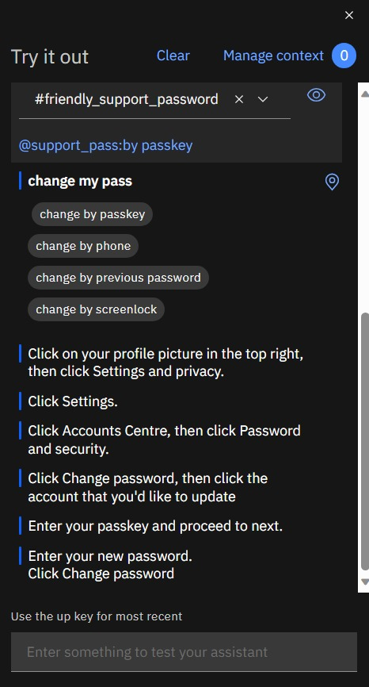

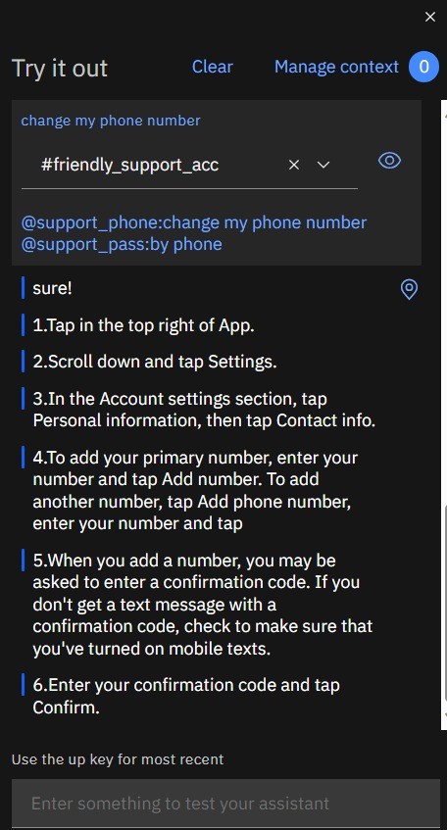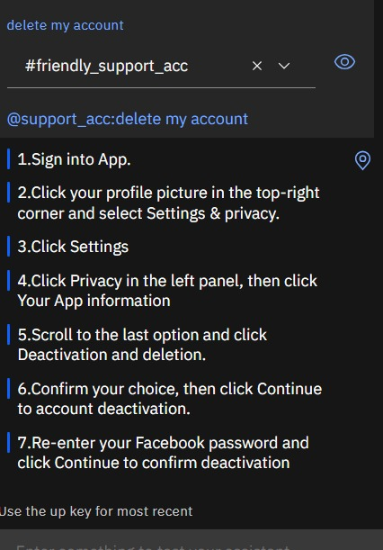

**INTENTS**

**1. Recognition of User Goals:**

**Intents are used to recognize the primary objective or goal that**

**a user is trying to achieve through their message.**

**For example, if a user types, "How to change my passwoprd," the intent might be recognized as "Change password."**

**2. Intent Training:**

**To teach the chatbot to recognize intents, you provide training data that includes examples of user messages mapped to specific intents. These examples help the chatbot learn the different ways users might express the same intent**.

**3. Intent Matching:**

**When a user sends a message to the chatbot, the platform uses natural language processing to analyze the message and determine which intent it best matches. This involves considering the context of the conversation and the words and phrases used.**

**4. Intent Confidence**:

**Watson Assistant provides a confidence score associated with each recognized intent. This score indicates the platform's level of confidence in the accuracy of the intent recognition. You can use this confidence score to determine how the chatbot should respond.**

**5. Response Routing:**

**Once the intent is identified, the chatbot can route the user to the appropriate dialog node or set of responses that are designed to handle that specific intent. This is how the chatbot provides contextually relevant answers.**

**6. Multi-Intent Recognition:**

**In some conversations, users may express multiple intents within a single message. Watson Assistant can recognize multiple intents within a single message and route the conversation accordingly.**

**7. Customization:**

**You can create custom intents based on the specific goals or tasks your chatbot is designed to handle. For instance, if you're building a customer support bot, you might define intents like "login issues," "Account settings," etc…**

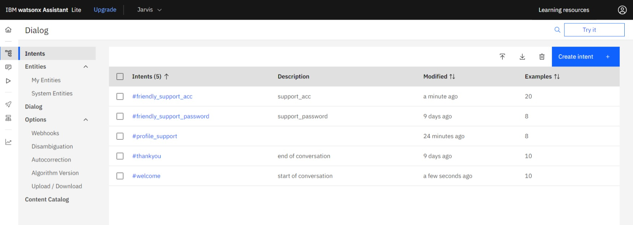

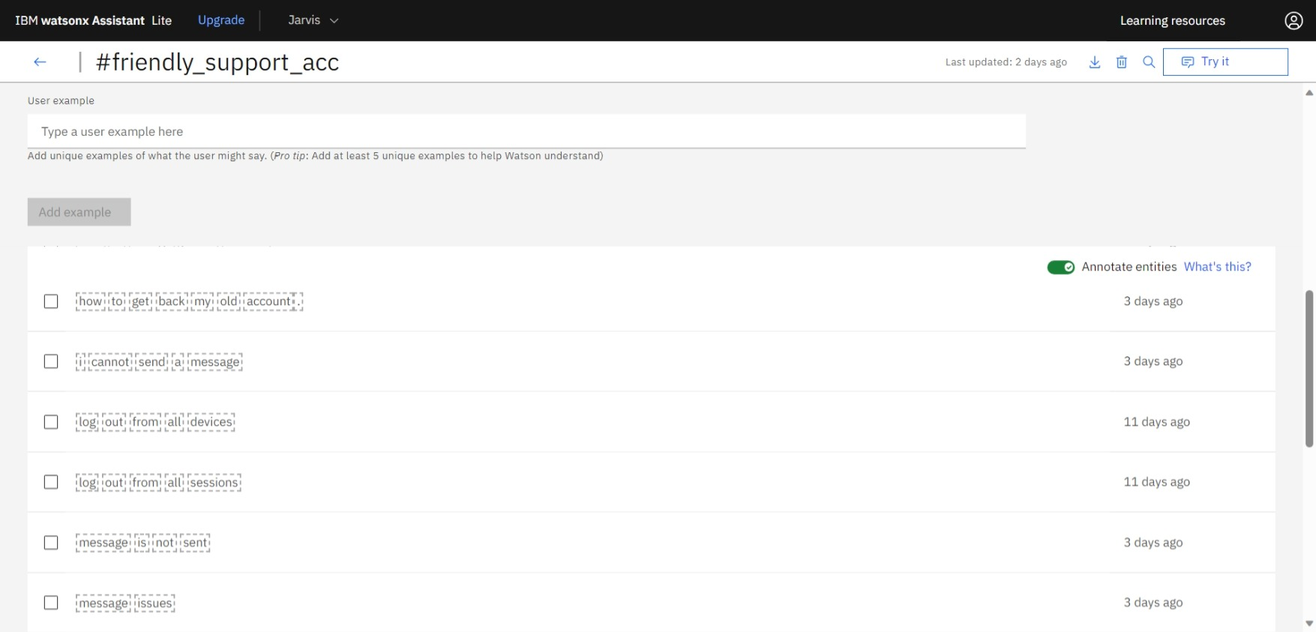

**Note: Please zoom to get a clear view of images**

**ENTITIES**

**1. Recognition of Structured Information:**

**Entities are used to identify and extract structured data from user messages. This structured data can be specific details such as dates, times, numbers, locations, product names, or any other relevant information.**

**2. Entity Types:**

**Watson Assistant supports various entity types, including system entities and user-defined entities. System entities are predefined for common concepts like numbers, dates, and times, while user-defined entities are created to match domain-specific data.**

**3. Training Data:**

**To teach the chatbot to recognize entities, you provide training data that includes examples of user messages containing the entities you want to extract. For instance, if you're building a chatbot for ordering pizza, you might create an entity called "PizzaTopping" and provide training examples like "I want a pizza with pepperoni."**

**4. Entity Values:**

**Within an entity type, you define entity values. For example, if you have an entity type "PizzaTopping," the entity values could be "Pepperoni," "Mushroom," and "Onion." These values represent the specific options that the chatbot should recognize within the entity.**

**5. Entity Matching:**

**When a user sends a message to the chatbot, the platform uses natural language processing to analyze the message and identify which entity values are present. For instance, if a user says, "I'd like a pizza with pepperoni and mushrooms," the chatbot might recognize the "PizzaTopping" entity with the values "Pepperoni" and "Mushroom."**

**6. Contextual Data:**

**Extracted entities are used to provide context and assist the chatbot in generating relevant responses. In the pizza example, the chatbot can use the identified pizza toppings to accurately fulfill the user's order.**

**7. Multiple Entities:**

**In a single message, users may mention multiple entities. Watson Assistant is designed to identify and extract multiple entities to enhance its understanding of user input.**

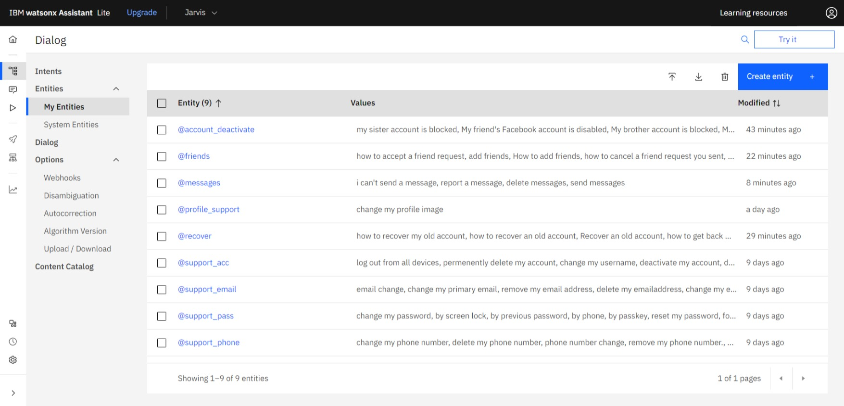

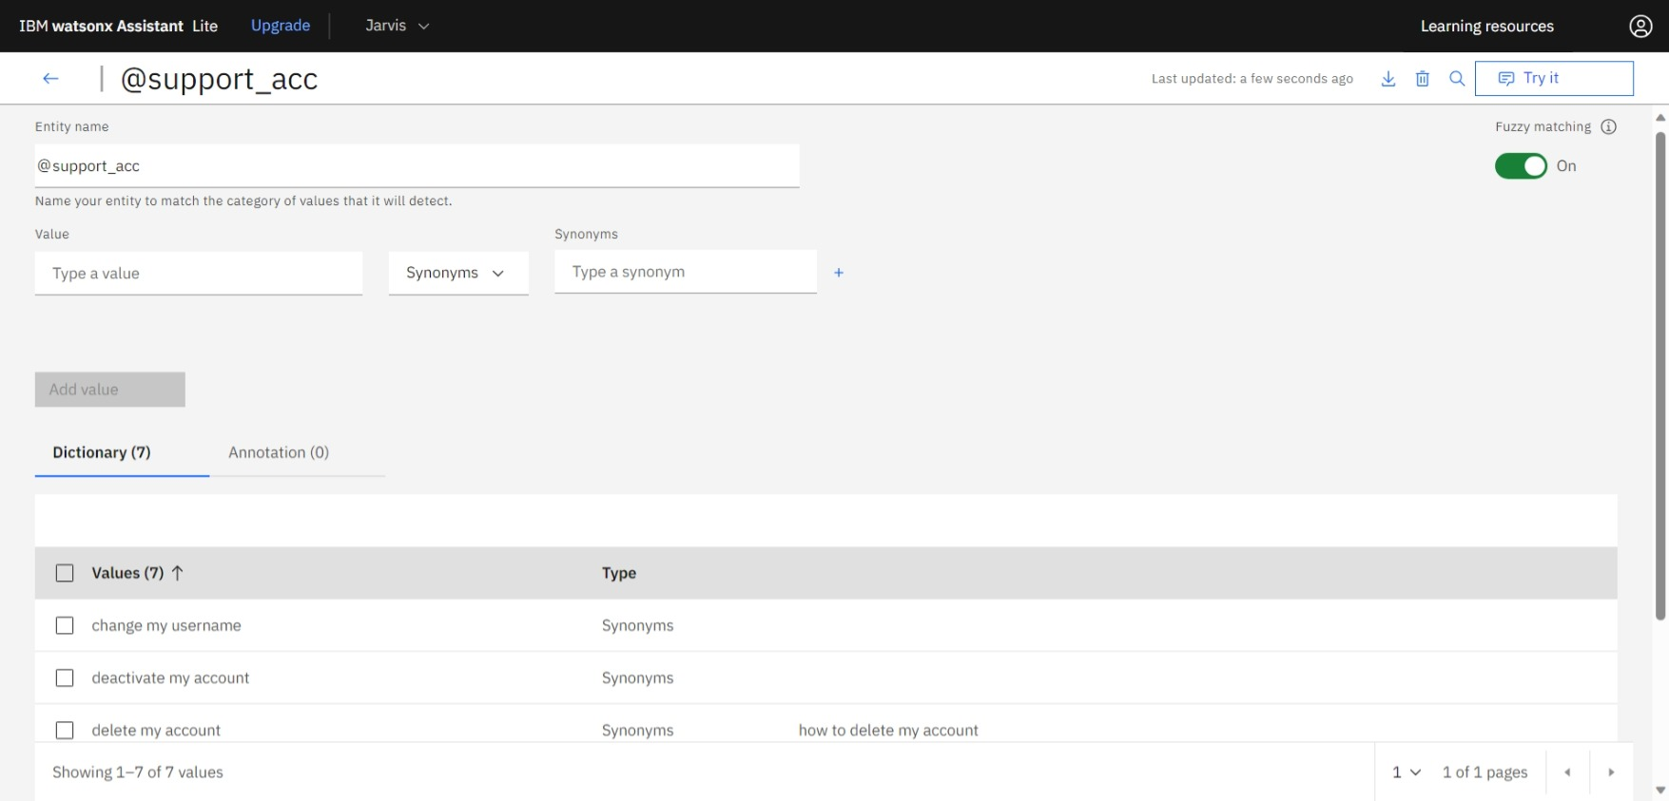

**DIALOGUE**

**1. Purpose:**

**Dialogue nodes are used to define the logic and responses of your chatbot. Each node represents a specific point in the conversation where the chatbot is expected to perform an action, respond to user input, or make decisions.**

**2. Conditions:**

**Dialogue nodes are often associated with conditions that determine when they should be triggered. Conditions can be based on intents (the user's goal), entities (specific pieces of information), context variables, or other criteria.**

**3. Responses:**

**Within a dialogue node, you can specify one or more responses that the chatbot should provide when the node is triggered. Responses can include text messages, images, suggestions, or even actions to execute.**

**4. Contextual Information:**

**Dialogue nodes can set, modify, or reference context variables. These variables store information about the conversation, allowing the chatbot to remember user-specific details and maintain context throughout the interaction.**

**5. Branching Logic:**

**Dialogue nodes allow you to define branching logic, which determines how the conversation flows based on user input. You can direct the conversation to different nodes depending on the user's intent, entity, or context.**

**6. Conditions and Slots:**

**You can set up conditions and slots in dialogue nodes to gather specific information from the user in a structured way. For instance, if the user wants to order a pizza, you can use slots to collect information like pizza size, toppings, and delivery address.**

**7. Custom Actions:**

**Dialogue nodes can contain custom actions, which allow you to execute code, make API calls, and perform custom logic in response to user input. This is useful for complex tasks and integrations.**

**8. Error Handling:**

**You can use dialogue nodes to handle unexpected user input or errors gracefully. You can create nodes to provide informative error messages and guide the conversation back on track.**

**9. Visual Interface: Many chatbot development platforms, including IBM Watson Assistant, offer a visual interface for creating and managing dialogue nodes. This makes it easy to design and structure the conversation flow.**

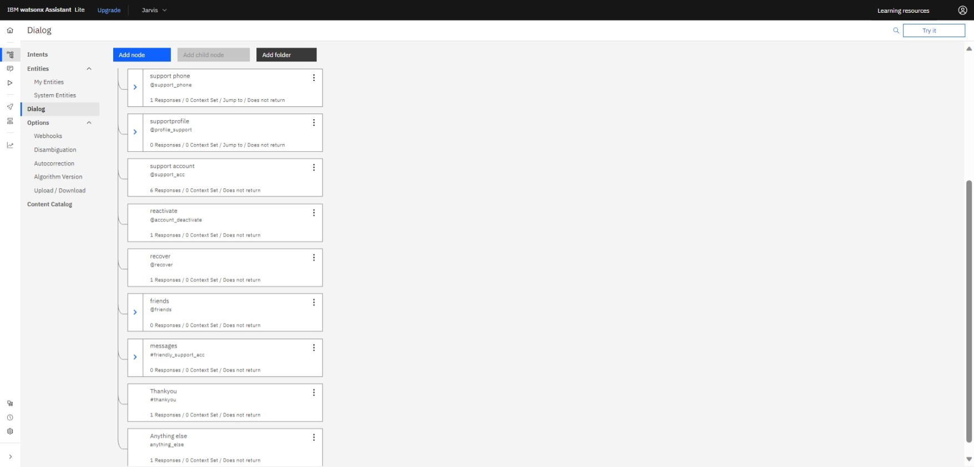

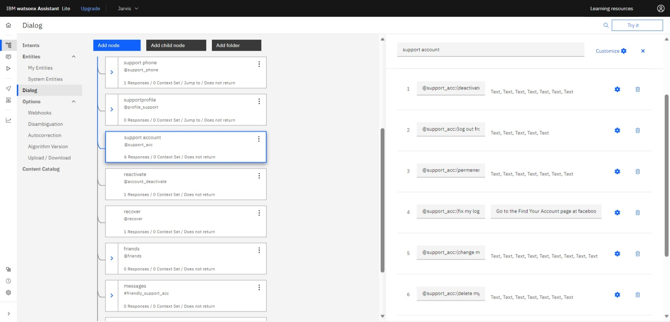

**META FOR DEVELOPERS**

**Meta for Developers, also known as the Meta Platforms Developer Platform, encompasses the set of tools and resources provided by Meta Platforms, Inc. (formerly Facebook) to enable developers to create applications and experiences that integrate with Meta's various products and platforms. These platforms include Facebook, Instagram, WhatsApp, Oculus, and other Meta-owned services.**

**1. APIs:**

**Meta provides application programming interfaces (APIs) that allow developers to access and interact with data and features on Meta's platforms. For example, the Facebook Graph API allows developers to work with Facebook data.**

**2. SDKs:**

**Software Development Kits (SDKs) are sets of tools and libraries that make it easier for developers to build applications for specific platforms. Meta offers SDKs for various platforms like Oculus, allowing developers to create virtual reality experiences.**

**3. Documentation:**

**Detailed documentation and resources are available to help developers understand and use Meta's tools effectively. This documentation provides guidelines, best practices, and code samples.**

**4. Developer Tools:**

**Meta may offer additional developer tools and resources, such as analytics, debugging tools, and testing environments to aid in the development and testing of applications.**

**5. Community Support:**

**Developers can often access support through developer forums, communities, and help centers to get assistance with their projects.**

**6. App Review Process:**

**When developers create applications that integrate with Meta's platforms, they may need to go through an app review process to ensure compliance with platform policies and security standards.**

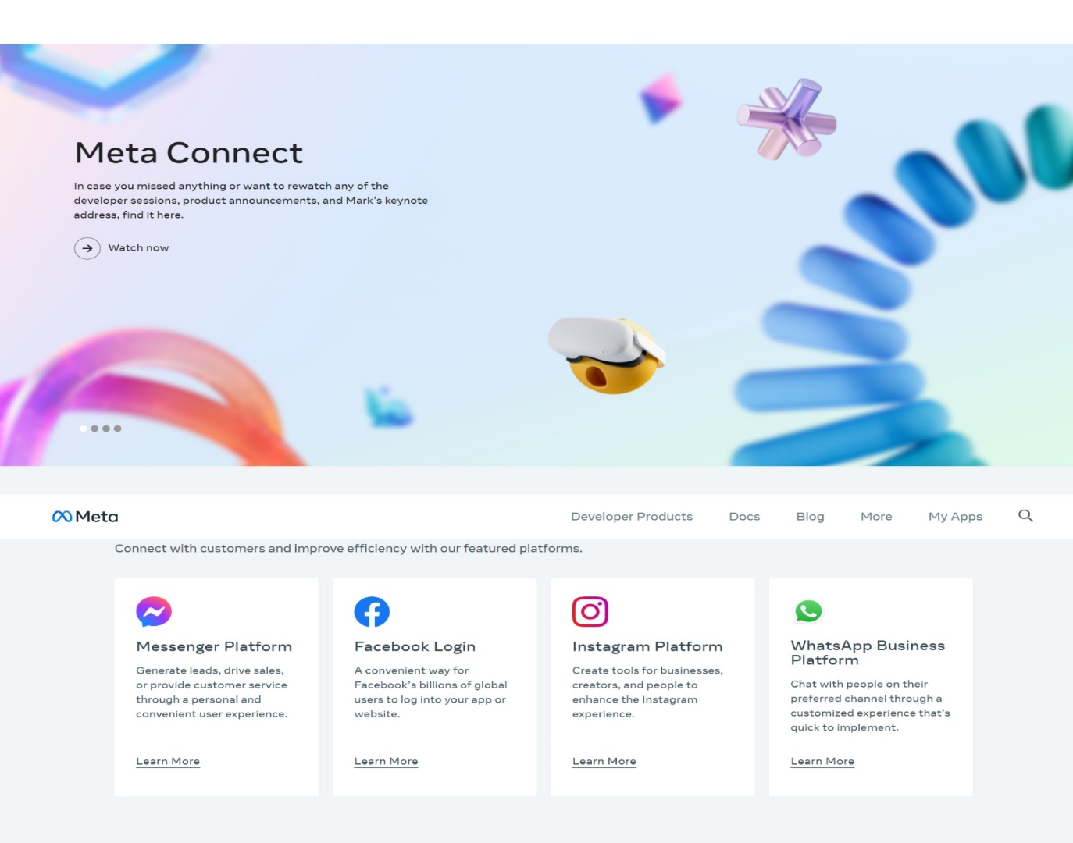

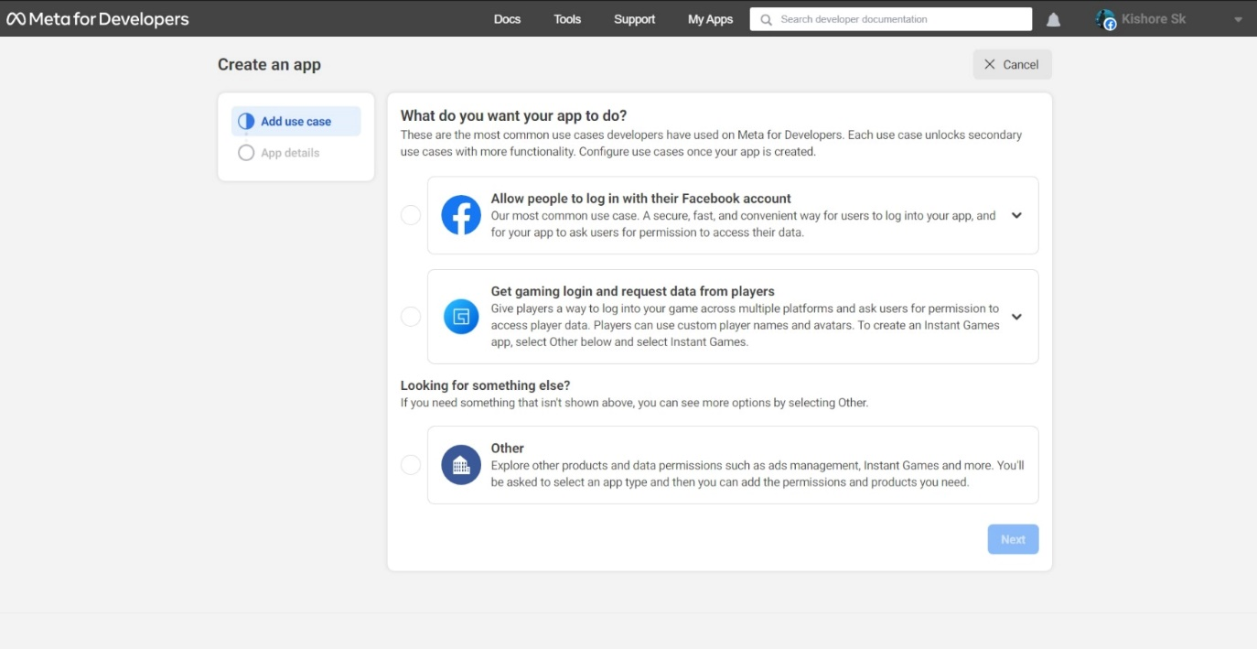

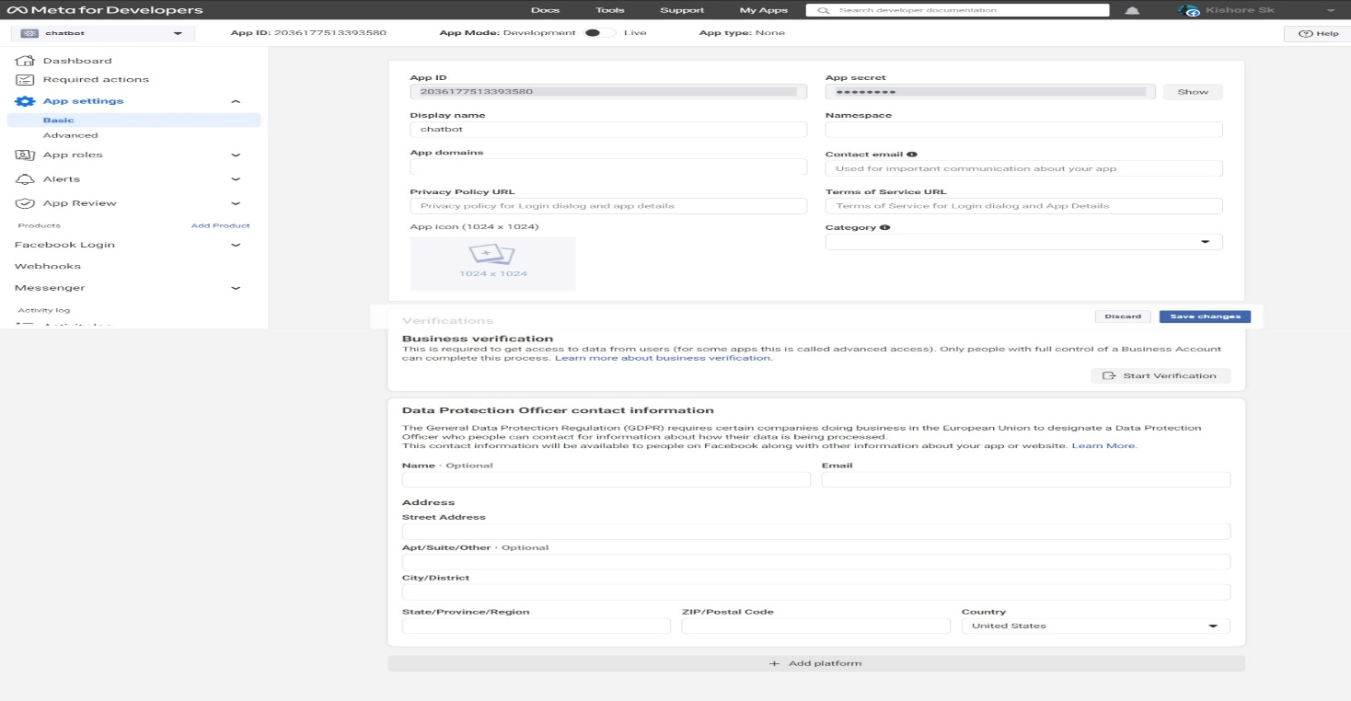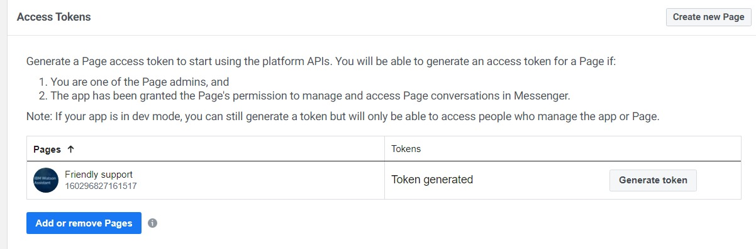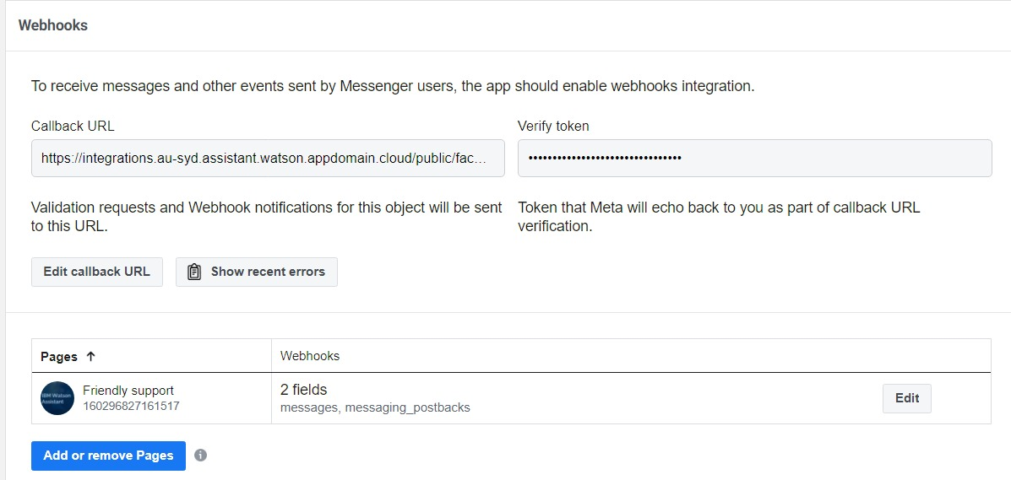INTEGRATING CHATBOT WITH MESSAGING PLATFORM

**1. Create a Watson Assistant Chatbot:**

**Start by creating a chatbot using IBM Watson Assistant. Define the intents, entities, and dialog flows that your chatbot will handle.**

**2. Choose a Messaging Platform:**

**Select the messaging platform where you want to integrate the chatbot. Common options include Facebook Messenger, Slack, or a custom web chat.**

**3. Integration Method:**

**Depending on the platform, you may need to use different integration methods. Common approaches include using APIs, webhooks, or SDKs provided by the messaging platform. Watson Assistant also provides a webhook integration option.**

**4. Develop the Integration:**

**Write code or scripts to connect the messaging platform to Watson Assistant. This often involves setting up a middleware that handles user messages, sends them to the chatbot, and relays the responses back to the user.**

**5. Authentication and Authorization:**

**Ensure you have the necessary credentials and permissions to access both the messaging platform and Watson Assistant.**

**6. Message Handling:**

**Implement logic to parse incoming messages, understand user intent, and send the appropriate queries to Watson Assistant.**

**7. Response Processing:**

**Handle responses from the chatbot and format them for display in the messaging platform.**

**8. Testing:**

**Thoroughly test the integration to make sure the chatbot functions correctly within the messaging platform. Test various user inputs and dialog flows.**

**9. Deployment:**

**Deploy the integrated chatbot on the messaging platform for users to interact with.**

**10. Monitoring and Maintenance:**

**Continuously monitor the chatbot's performance, gather user feedback, and make improvements to the chatbot's responses and capabilities.**

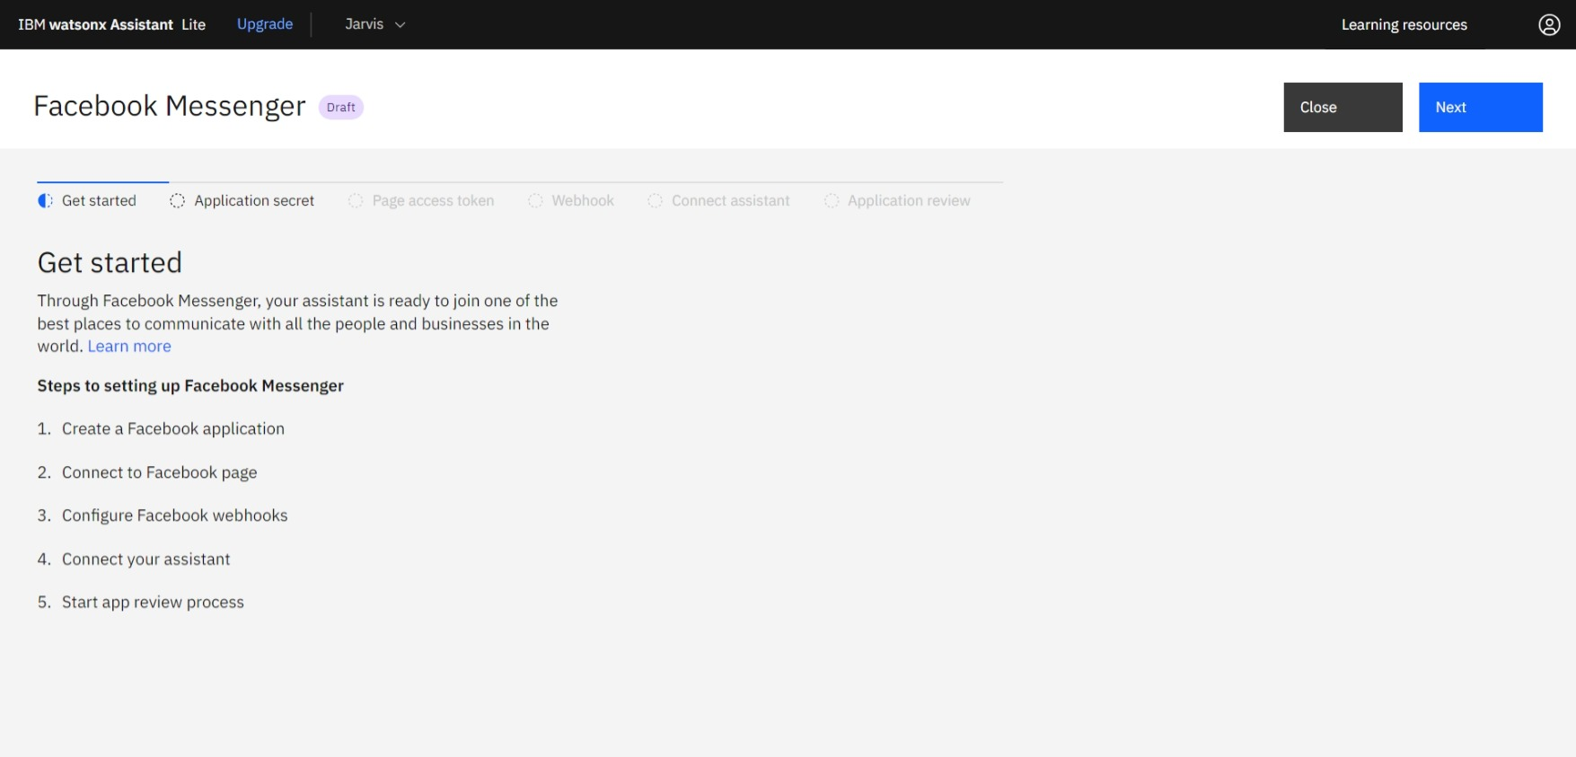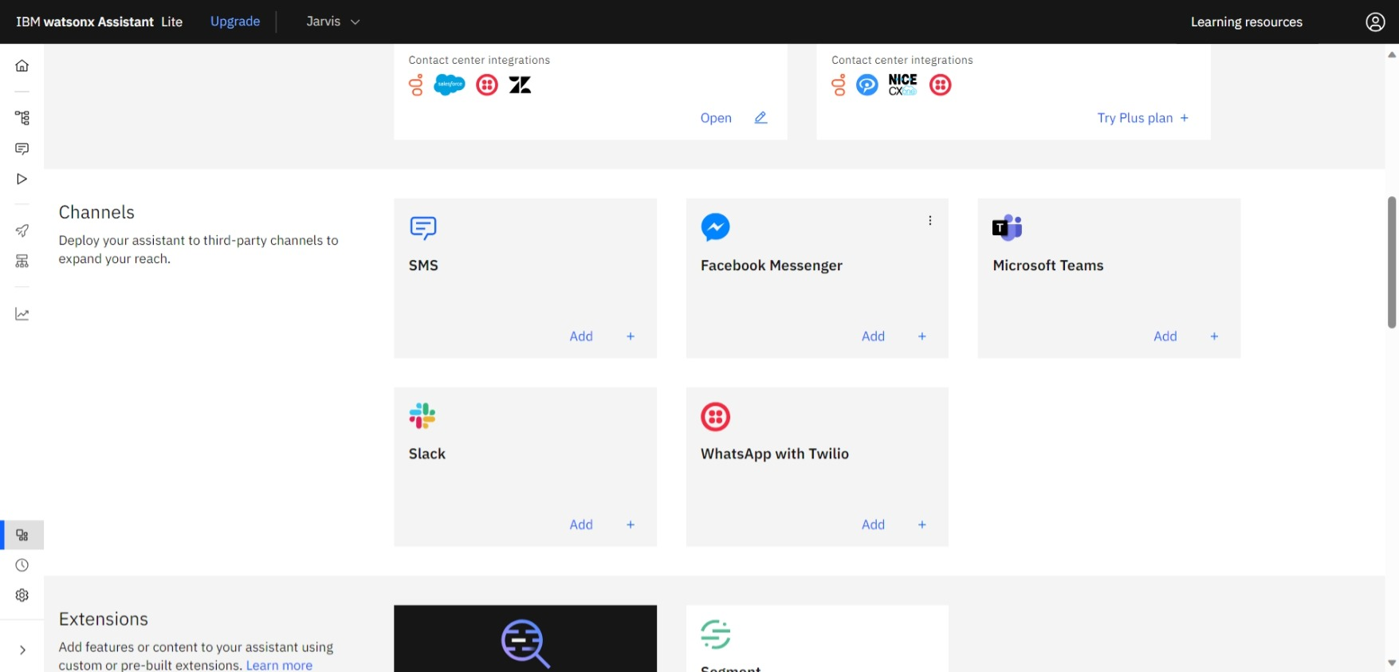

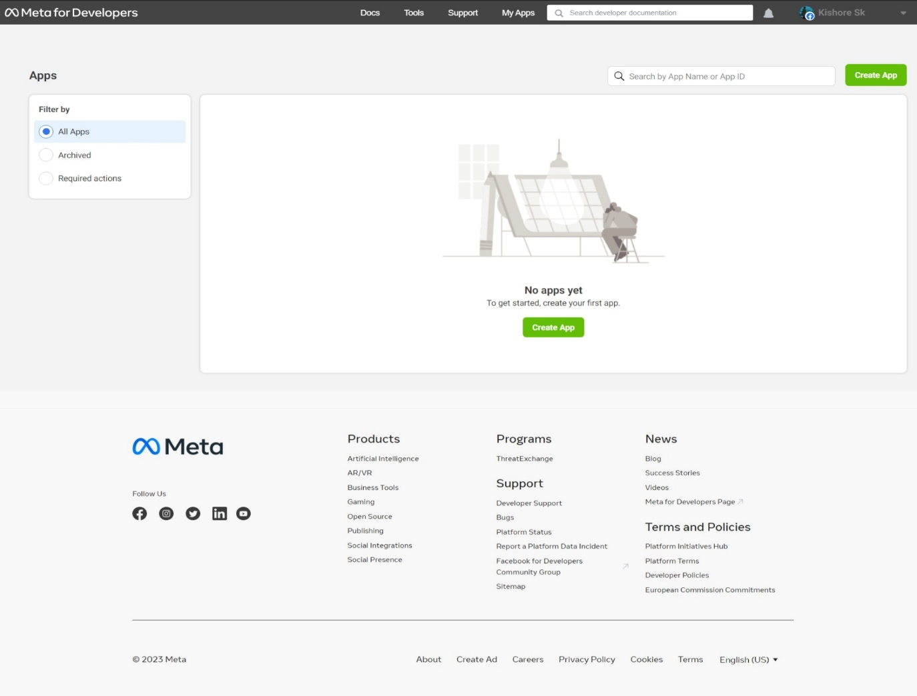

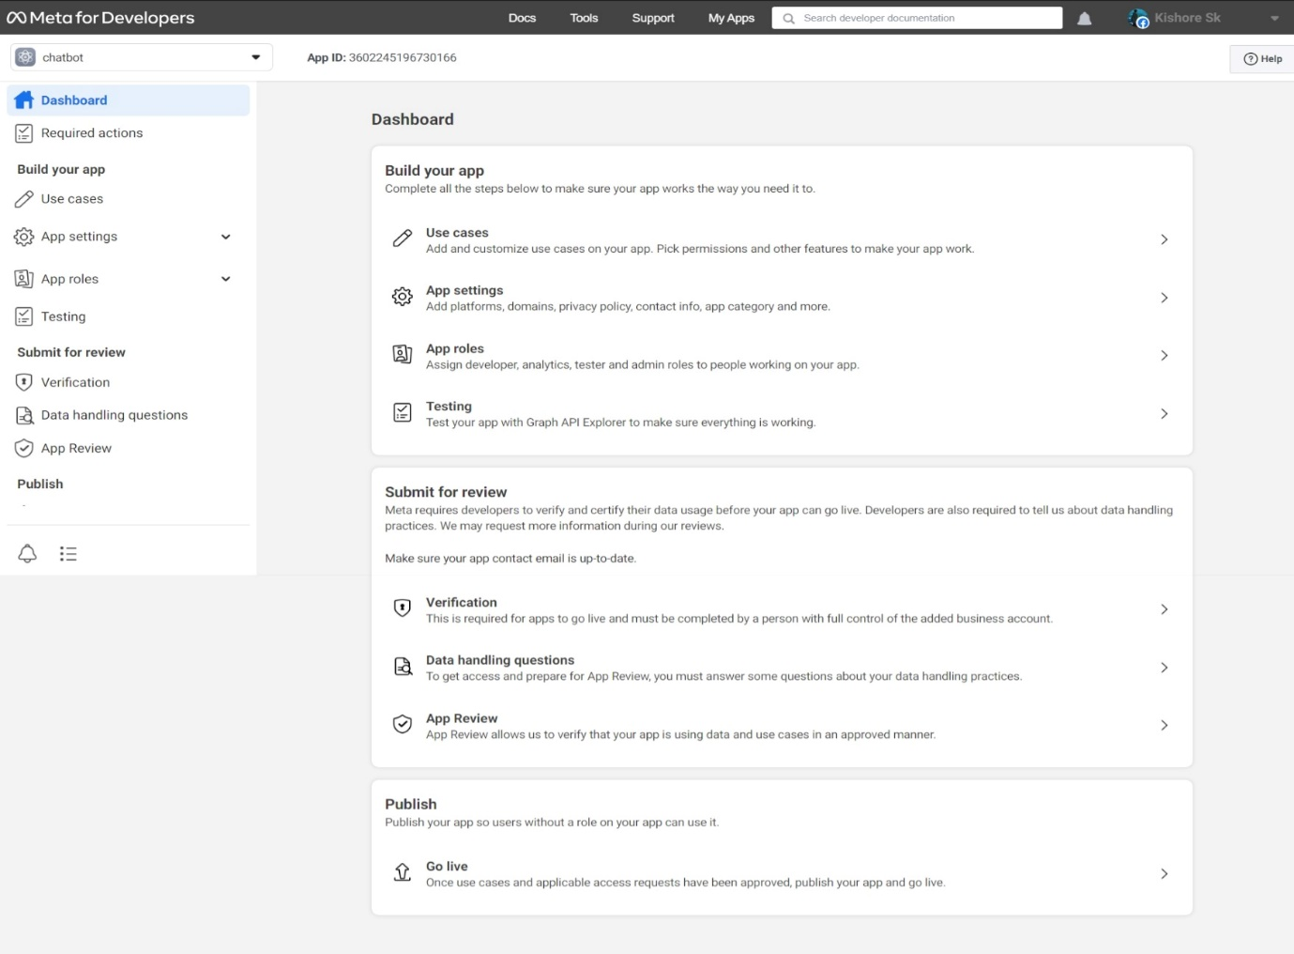

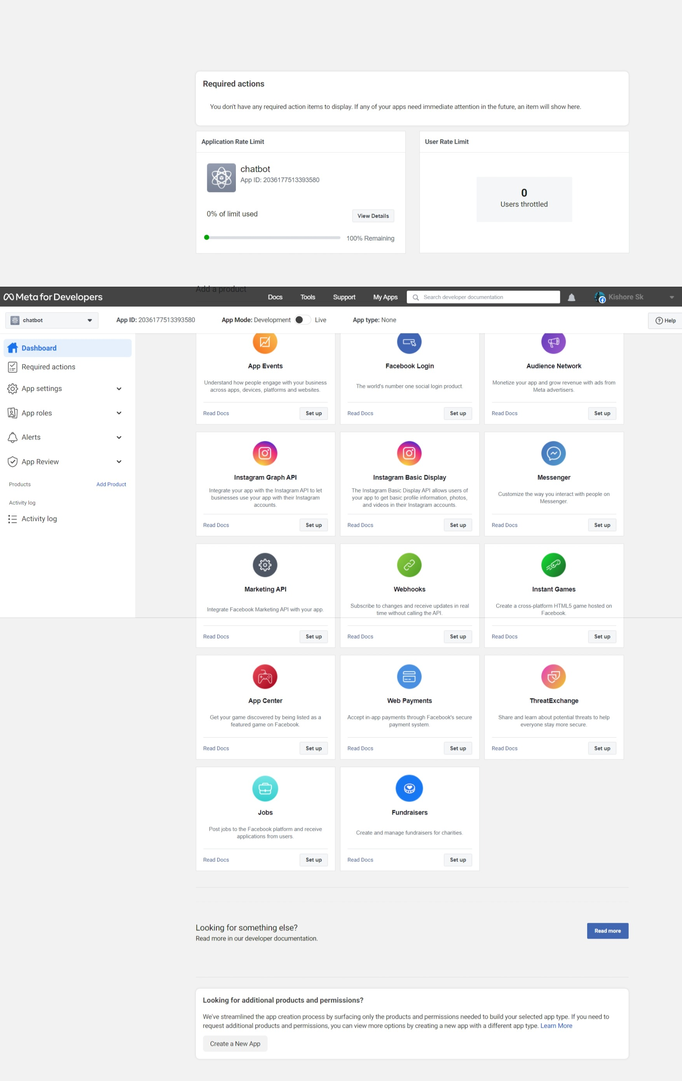

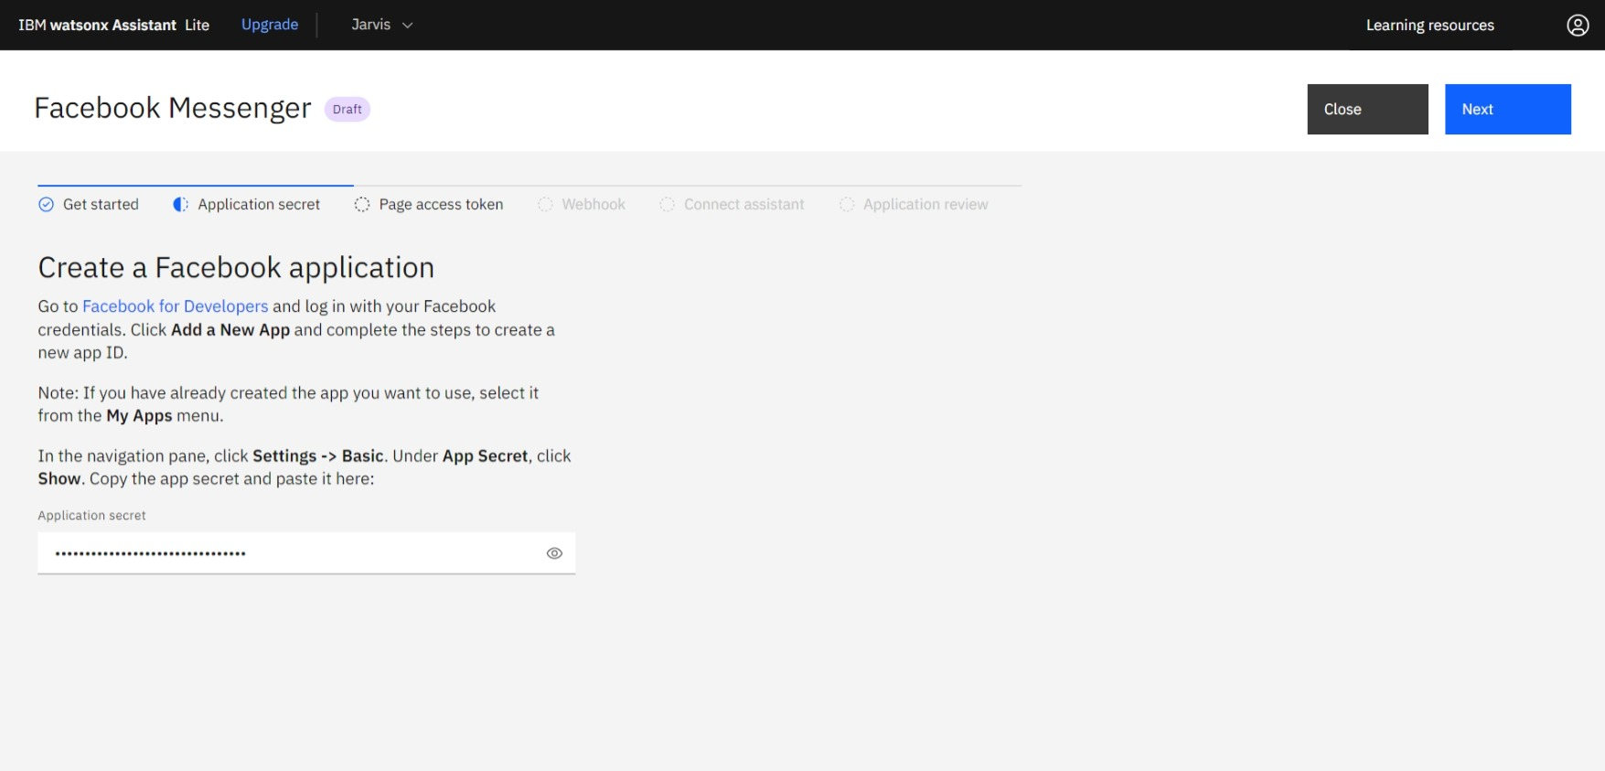

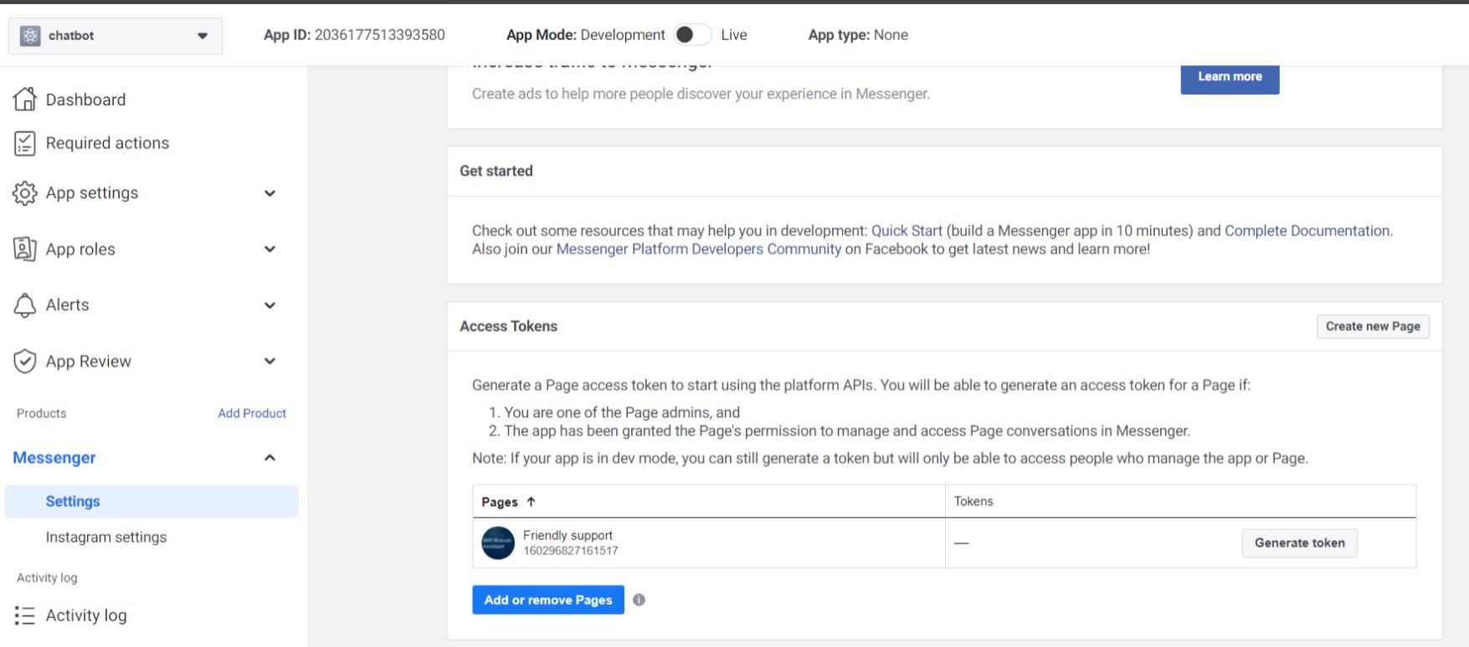

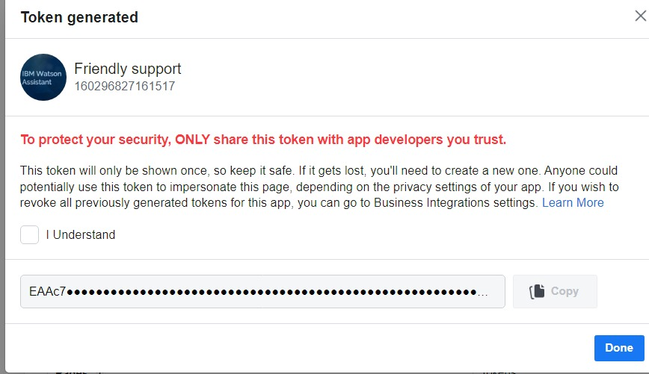

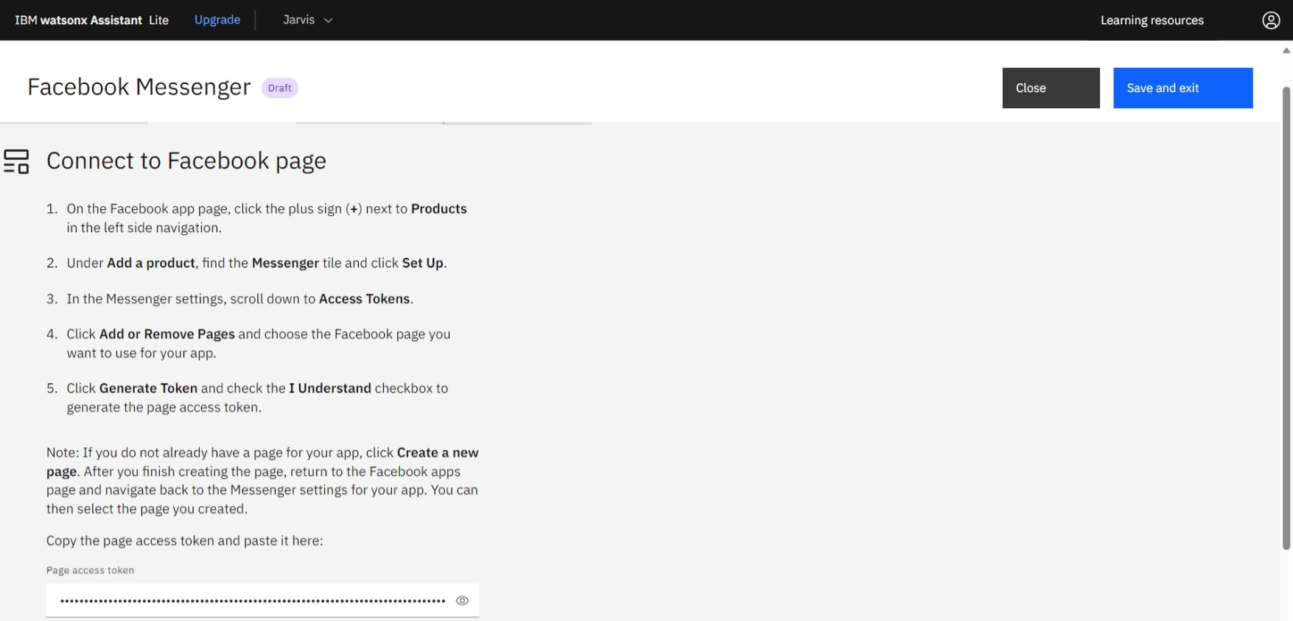

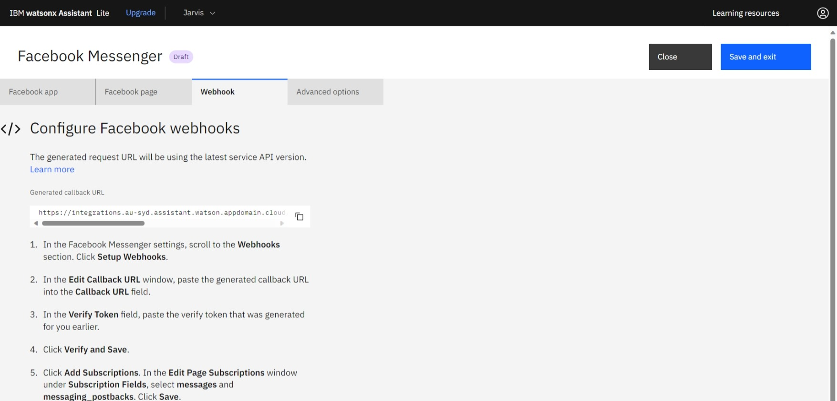

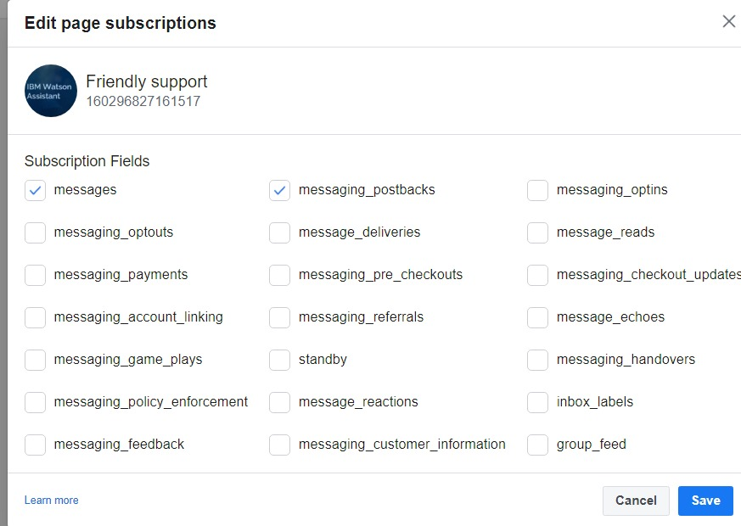

CHATBOT ON FACEBOOK

**1. Create a Watson Assistant Chatbot:**

**Start by creating a chatbot using IBM Watson Assistant. Define the intents, entities, and dialog flows that your chatbot will handle.**

**2. Set Up a Facebook Page:**

**If you don't already have one, create a Facebook Page for your business or organization. This is where your chatbot will interact with users.**

**3. Create a Facebook App:**

**You'll need to create a Facebook App to access the Messenger API. Go to the Facebook for Developers website, create a new app, and configure the app settings.**

**4. Get Page Access Token:**

**Within your Facebook App settings, obtain a Page Access Token. This token will allow your app to send and receive messages on behalf of your Facebook Page.**

**5. Set Up Webhooks:**

**Configure the webhook for your Facebook App. This is where Facebook will send incoming messages to your chatbot. You'll need to specify a callback URL for your server where you'll handle incoming messages.**

**6. Develop the Integration:**

**Write code or scripts to connect your Watson Assistant chatbot to Facebook. You'll need a server to handle the incoming messages and send them to Watson Assistant. Use the Page Access Token to send responses back to Facebook Messenger.**

**7. Authentication and Authorization:**

**Ensure you have the necessary credentials and permissions to access both Facebook and Watson Assistant.**

**8. Message Handling:**

**Implement logic to parse incoming messages from Facebook, understand user intent, and send the appropriate queries to Watson Assistant.**

**9. Response Processing:**

**Handle responses from Watson Assistant and format them for display in Facebook Messenger.**

**10. Deployment:**

**Deploy the integrated chatbot on your Facebook Page for users to interact with.**

